1. USING STATIC METHODS:

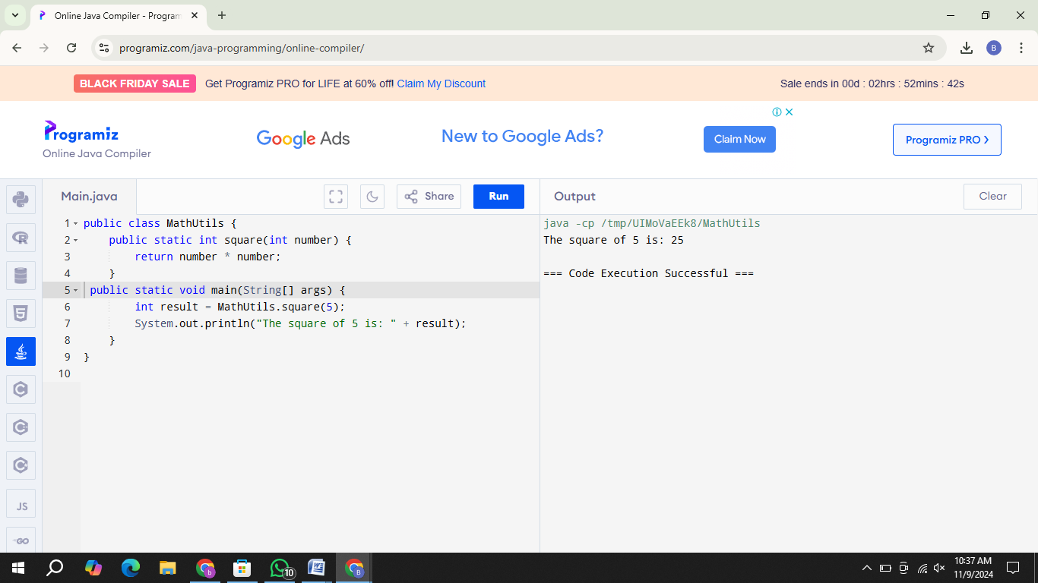

1. USING STATIC VARIABLE METHODS:

